An Asymmetric Solid Electrolyte with Engineered Layers for Dendrite-Free Li-metal Battery

Hui Duan, Shuang-Jie Tan, Ya-Xia Yin, Li-Jun Wan, Yu-Guo Guo*
CAS Key Laboratory of Molecular Nanostructure and Nanotechnology, Institute of Chemistry, Chinese Academy of Sciences (CAS), Beijing 100190, P. R. China
Email:ygguo@iccas.ac.cn, web site: http://mnn.iccas.ac.cn/guoyuguo/

Li-metal has been intensively pursued as an exceptional anode material for higher energy density batteries due to its high theoretical specific capacity (3860 mA h g⁻¹), and the lowest redox potential (−3.040 V vs the standard hydrogen electrode). Nevertheless, the development of Li-metal batteries with liquid electrolytes is hindered by the formation of lithium dendrites, which lead to serious and sporadic safety issues. Replacing liquid electrolytes with solid-state electrolytes is an effective strategy to achieve practical Li-metal batteries free of the safety issues.[1] The key bottleneck troubling the application of solid electrolyte is the contradictory requirements from Li-metal and cathode, which need high modulus to block Li-dendrite penetration and flexibility to enable low interface resistance, respectively. This study describes a thin asymmetrical design of solid electrolyte to address these shortcomings. In this architecture, a rigid ceramic-layer modified with an ultrathin polymer is toward Li-metal to accomplish dendrite-suppression of Li-anode, and a soft polymer-layer spreads over the exterior and interior of cathode to endow connected interface simultaneously.[2] This ingenious arrangement endows solid Li-metal batteries with extremely high Coulombic efficiency and cycle-ability. This work will open up one avenue for realizing safe and long-life energy storage systems.

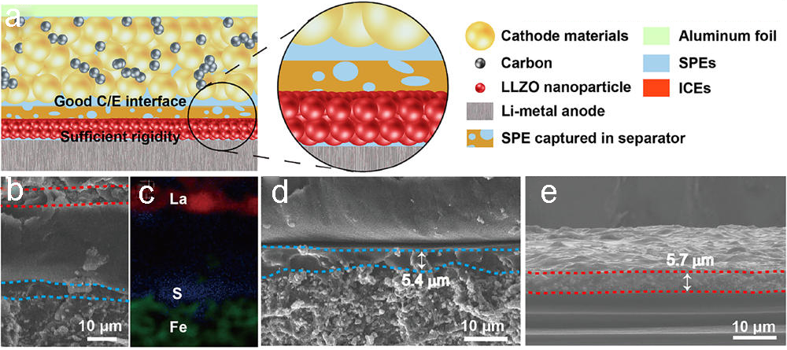
Fig. 1 Schematic diagrams and structure characterizations of solid Li-metal battery with asymmetric solid electrolyte

- S. Xin, Y. You, S. F. Wang, H. C. Gao, Y. X. Yin and Y. G. Guo, ACS Energy Lett 6, 1385(2017)
- H. Duan, Y. X. Yin, Y. Shi, P. F. Wang, X. D. Zhang, C. P. Yang, J. L. Shi, R. Wen, Y. G. Guo, L. J. Wan, J. Am. Chem. Soc. 140, 82(2018)

